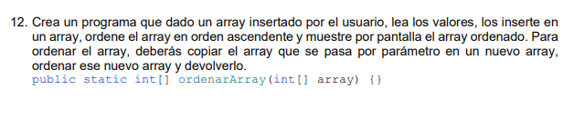
import java.util.Arrays;
public class TestArrays {
public static int[] ordenArray(int[] array) {
int[] arraycopy = Arrays.copyOf(array, array.length);
Arrays.sort(arraycopy);
return arraycopy;
}
}
public static void main(String[] args) {
int[] fuente = {9, 18, 25, 7, 24};
int[] ordenado = TestArrays.ordenArray(fuente);
System.out.println(Arrays.toString(ordenado));
}

